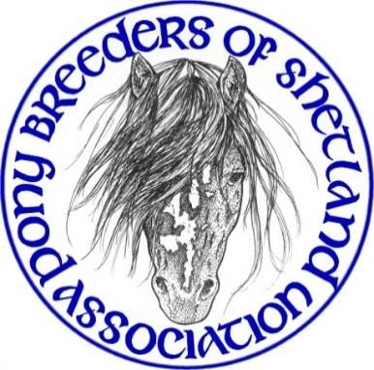YOUNGSTOCK SHOW

Sunday 24th November 2024 Shetland Rural Centre, Staneyhill, Lerwick

Judging from 10.00am

Affiliated to the Shetland Pony Stud Book Society

Entry fee £5.00 per pony per class PBSA members/£8.00 non-members

Entries accepted NO LATER than Sunday 10th November 2024

Judge: Mrs Doreen Tindale, Staffordshire (Abbeyfield)

**SCHEDULE**

Class No

1. Young Handler (3 – 9 years)

2. Young Handler (10 – 16 years)

**Best Young Handler** – 1st placed from classes 1 & 2 to compete

Ponies in Young Handler classes do not need to be entered in any of the following classes.

1. Miniature Colt Foal 4. Miniature Filly Foal

5. Standard Colt Foal 6. Standard Filly Foal

**Best Foal and Reserve** – 1st placed from classes 3, 4, 5 & 6 to compete.

7. Miniature Yearling Colt or Gelding (born 2023) 8. Miniature Yearling Filly (born 2023)

9. Standard Yearling Colt or Gelding (born 2023) 10. Standard Yearling Filly (born 2023)

**Best Yearling and Reserve** – 1st placed from classes 7, 8, 9 & 10 to compete.

11. Miniature 2 yr old Colt or Gelding (born 2022) 12. Miniature 2 yr old Filly (born 2022)

13. Standard 2 yr old Colt or Gelding (born 2022) 14. Standard 2 yr old Filly (born 2022)

**Best 2 Year Old and Reserve** – 1st placed from classes 11, 12, 13 & 14 to compete.

15. Miniature 3 yr old Colt or Gelding (born 2021) 16. Miniature 3 yr old Filly (born 2021)

17. Standard 3 yr old Colt or Gelding (born 2021) 18. Standard 3 yr old Filly (born 2021)

**Best 3 Year Old and Reserve** – 1st placed from classes 15, 16, 17 & 18 to compete.

# Youngstock Champion & Reserve Champion

To be chosen from 8 ponies – Best Foal, Reserve Best Foal, Best Yearling, Reserve Best Yearling, Best 2 Year Old, Reserve Best 2 Year Old, Best 3 Year Old and Reserve Best 3 Year Old to compete.

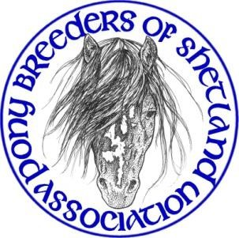**Youngstock Show Rules & Conditions of Entry**

Entry fee £5.00 per class PBSA members/ £8.00 non-members Entries accepted NO LATER than Sunday 10th November 2024

**General**

* The show is affiliated to the Shetland Pony Stud Book Society and is run under their rules. Exhibitors must familiarise themselves with these rules prior to exhibiting.
* All ponies must be registered in the UK Shetland Pony Stud-Book.
* All ponies must be named on the entry form.
* Three-year-old fillies with foals at foot may not be shown.
* All foals must be a minimum of three weeks old on the day of the Show.
* Competing ponies must be the bona-fide property of exhibitors or held on a SPS-BS lease form, and must have been in their possession, on Shetland, for at least four weeks prior to the date of the show. Please ensure all transfers of ownership/lease forms are up to date as entries will be checked against SPS-BS records.
* Owners who have had ponies suffering from an infectious disease within six weeks of the show must not present any ponies for show.
* If any pony is suspected of or found to be suffering from an infectious or contagious disease or any other condition preventing it from being shown it must be removed from the show immediately upon request of the show committee or a vet.
* The Show committee reserves the right to amend, amalgamate, split or cancel any class and to replace a judge if necessary.
* Judging to commence at 10am prompt. Once judging of a class has commenced, no late arrivals will be admitted to the ring.
* After the conclusion of the Championship if the winners of the Best Standard or Best Miniature trophies have not become apparent through the awarding of Champion and Reserve these trophies will be determined from the 1st prize winners from their respective classes.
* Any objection must be made in writing to the Show Committee within one hour of the alleged incident, with a deposit of £20, which will be refunded should the objection be upheld.
* The decision of the Judge and the Show Committee is final.

**Exhibitors**

* Exhibitors’ numbers will be available from the Secretary and the correct number must be displayed on the handler at all times.
* Whips/show canes carried must not exceed 30” in length.
* All children under the age of 16 years must wear a hard hat while exhibiting.
* Entire males aged 2 years and over must be shown bitted and it is advised that they display a stallion badge on their bridle.
* No child under 14 years may be in charge of an entire male (excluding foals) in the ring.
* There must be no colts or stallions in Young Handler classes.
* Young Handlers must be a minimum of 3 years of age on the day of the show.
* Exhibitors must not kneel but remain standing at all times whilst in the ring.
* It is the responsibility of each exhibitor/competitor to ensure that the ring, surrounding area and car park are left clean and tidy at the end of the show.

**Neither the PBSA Youngstock Show nor its organisers will be held liable for anything that may happen from any cause or circumstance whatsoever to any person, animal, article property. It is a condition of entry the each exhibitor/competitor shall indemnify the show against any such matter aforesaid when signing the entry form. By signing the entry form exhibitors agree to abide by the rules, code of conduct and procedures of the Pony Breeders of Shetland Association.**

# PBSA Youngstock Show 2024 Entry Form

## Entry Fees £5.00 per class for PBSA members/£8.00 per class for non-members Closing date for entries Sunday 10th November 2024, no late entries accepted

**Class sponsorship would be greatly appreciated at £15 per class. Please make 3 choices below as your first choice may not be available.**

**1. 2. 3.**

|  |  |  |  |  |  |  |
| --- | --- | --- | --- | --- | --- | --- |
| **Cat No** | **Class No.** | **Standard/**  **Miniature** | **Name of Pony** | **Stud Book**  **No.** | **Entry Fee** | |
|  |  |  |  |  |  | |
|  |  |  |  |  |  | |
|  |  |  |  |  |  | |
|  |  |  |  |  |  | |
|  |  |  |  |  |  | |
|  |  |  |  |  |  | |
|  |  |  |  |  |  | |
|  |  |  |  |  |  | |
| Forms Should Be Returned To:  **Arianne Sandison**  **29 Blydoit Park**  **Scalloway**  **ZE1 0UG**  **Tel: 07551 981627**  **Email:** [**arianne.charlotte@hotmail.co.uk**](mailto:arianne.charlotte@hotmail.co.uk) **Cheques Made Payable to: Pony Breeders of Shetland Association**  **Bank Details available on request** | | | **Name: Address:**  **Email: Tel:** | **Entry Fees** |  | |
| **Sponsorship** |  | |
| **Prepaid Catalogue (Tick if required)** | **£2.00** |  |
| **Total:** |  | |
|  | | |

**Neither the PBSA Youngstock Show nor its organizers will be held liable for anything that may happen from any cause or circumstance whatsoever to any person, animal, article property. It is a condition of entry the each exhibitor/competitor shall indemnify the show against any such matter aforesaid when signing this entry form. By signing this entry form exhibitors agree to abide by the rules, code of conduct and procedures of the Pony Breeders of Shetland Association.**

**Signature: Date:**